Project 6153

Business Case

Customer inspects serialized parts at certain points in production. They would like to capture the results of those inspections and use those results to better control how serial numbers progress to next manufacturing steps. Inspections happen quickly, so the inspection entry screen should be optimized for speed and barcode scanning.

Solution

Create a custom GAB script to capture inspection results and allow for fast barcode scanning of information during inspection. This GAB script must also check each serial number as it is being entered to make sure that it passed inspection at all previous inspection points. Finally, the script will allow for re-inspection of serial numbers and release parts passing inspection to go to the next step. Create a custom GAB script for a screen to enter defect categories per workcenter. Create a custom dashboard to display all inspection results and allow filtering, sorting, and export to Excel. Create a custom GAB script to validate the inspection status of serial numbers during the WIP to FG process.

Defect Category Screen – Select WorkCenter and Enter in Category

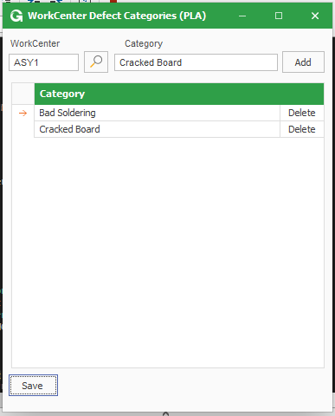

Update Work Order Screen – This is were the Inspection occurs and where the Serial Numbers gets attached to the Job-Suffix (This info in saved to a Custom Table)

\*Note – Only one Job can be processed at a time.

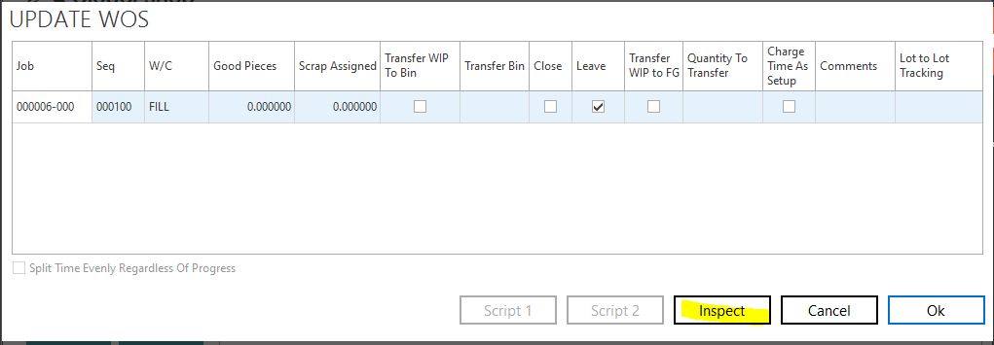

Inspection Screen – Serial Number is entered. Inspection Status is selected (Pass, Quick Fix, Reject), Defect Category Selected and Comments can be entered.

Click save. For all serials entered with a Pass Status the number will be passed back to the update wo grid as good pieces.

Also only Workcenters that have Defect Categories set up can inspect a Serial.

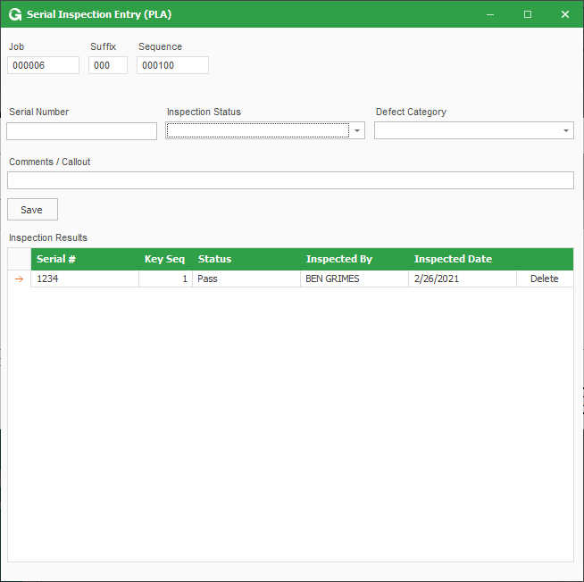

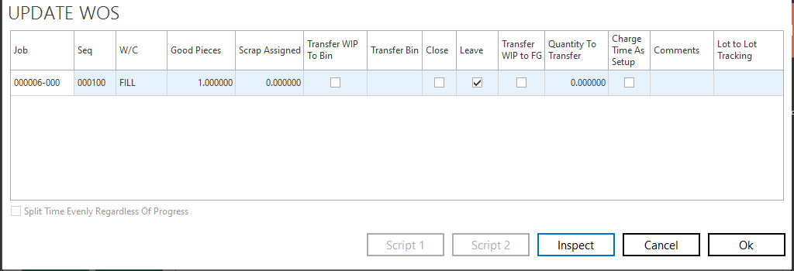

WIP TO FG Screen – Lot Bin Serial Number Assignment – On the Save a script is attached to check to make sure the serial has passed the last labor step that requires inspection before adding serial record to the grid.

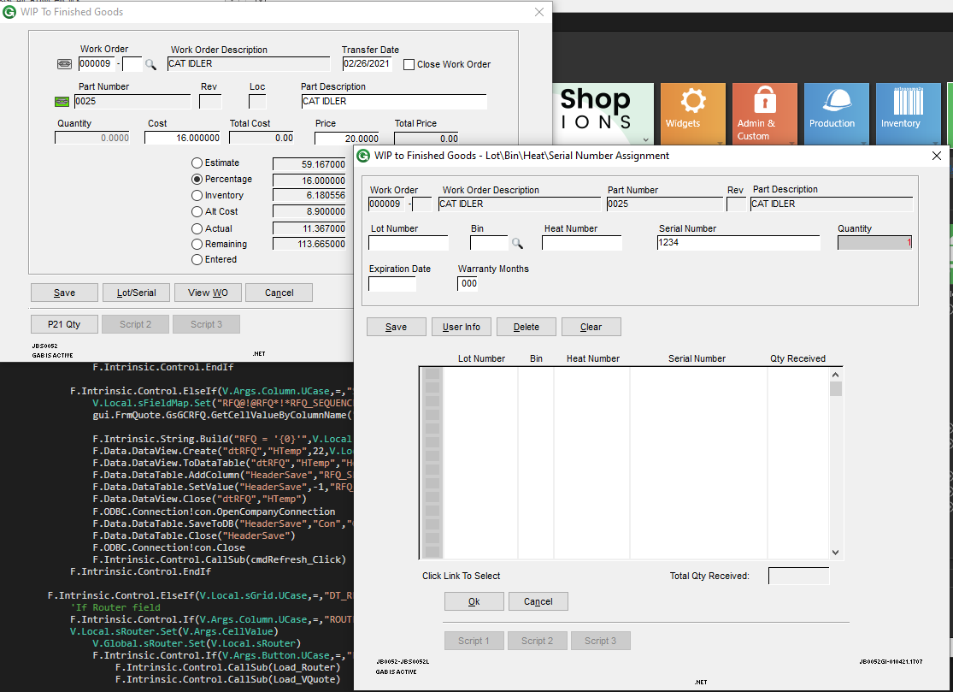

Inspection Dashboard. (See all inspection status for selected date range)

